**Assignment-3**

# **Creating an IAM User and Granting Full S3 Access**

## **Objective:-**

Learn how to create an IAM user in AWS, assign permissions through a group, and grant full access to the S3 service.

## **Prerequisites:-**

1. AWS Management Console access.
2. Permissions to create IAM users and groups in your AWS account.

# **Step to follow:-**

## **Creating an IAM User:**

* 1. **Sign In**: Log in to the AWS Management Console and open the **IAM Console**.

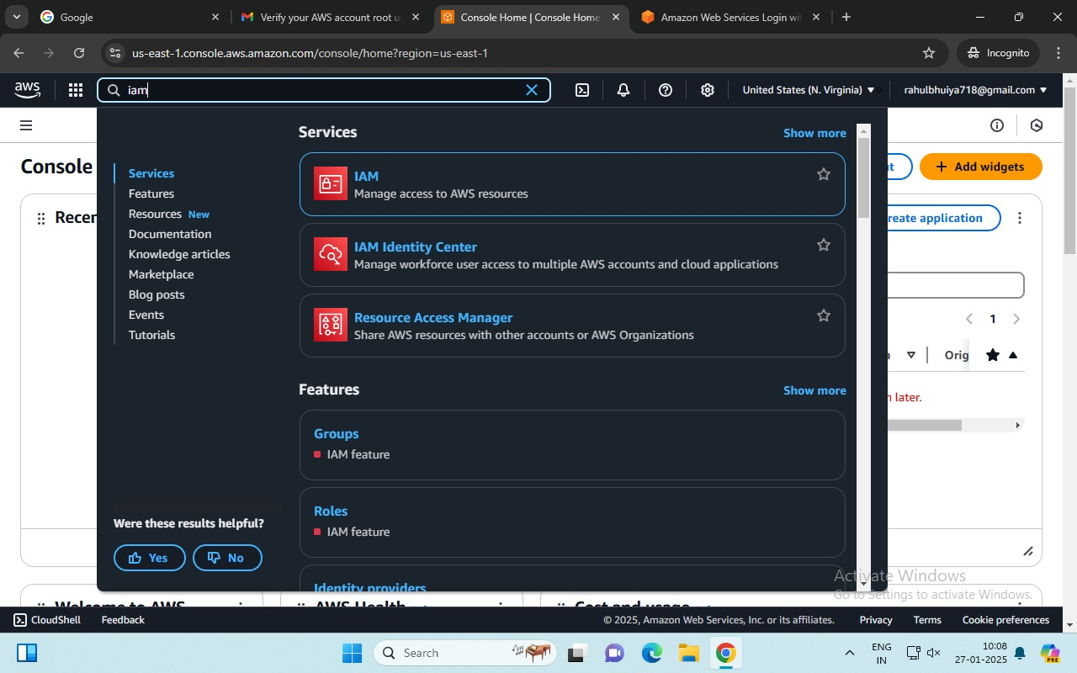

## **Navigate to Users:**

* + - In the left-hand navigation pane, select **Users**.
    - 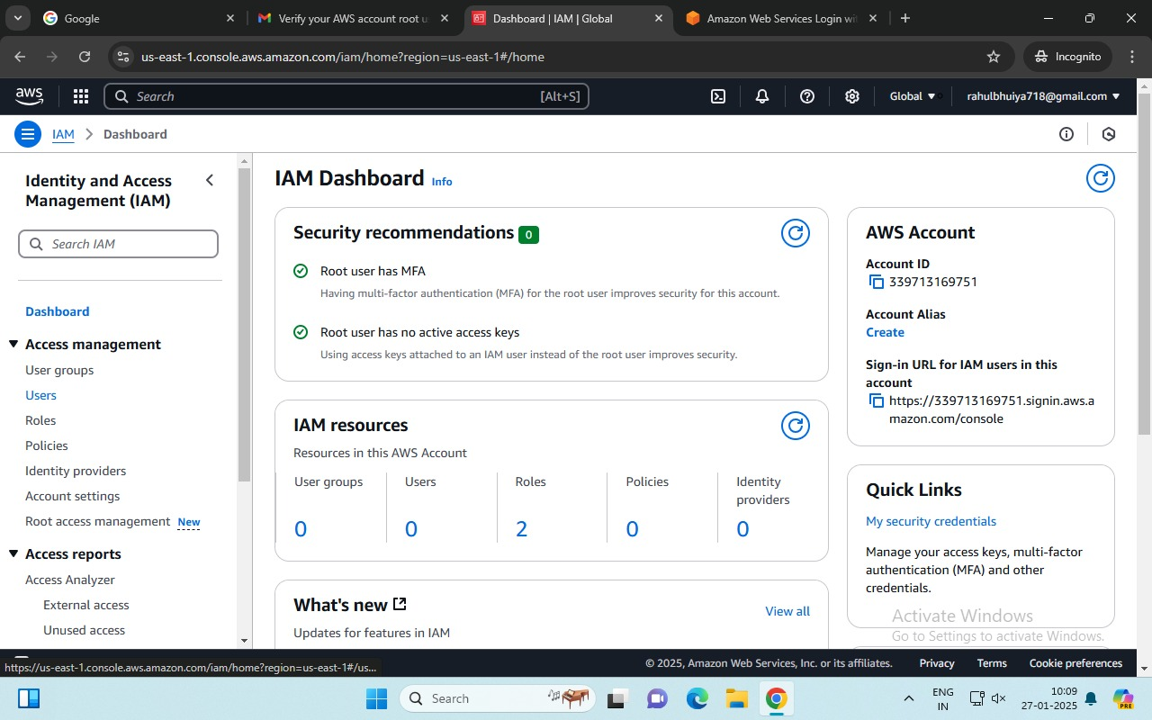Click **Add user**.

**(Access Management (Left Hand Side) -> User).**

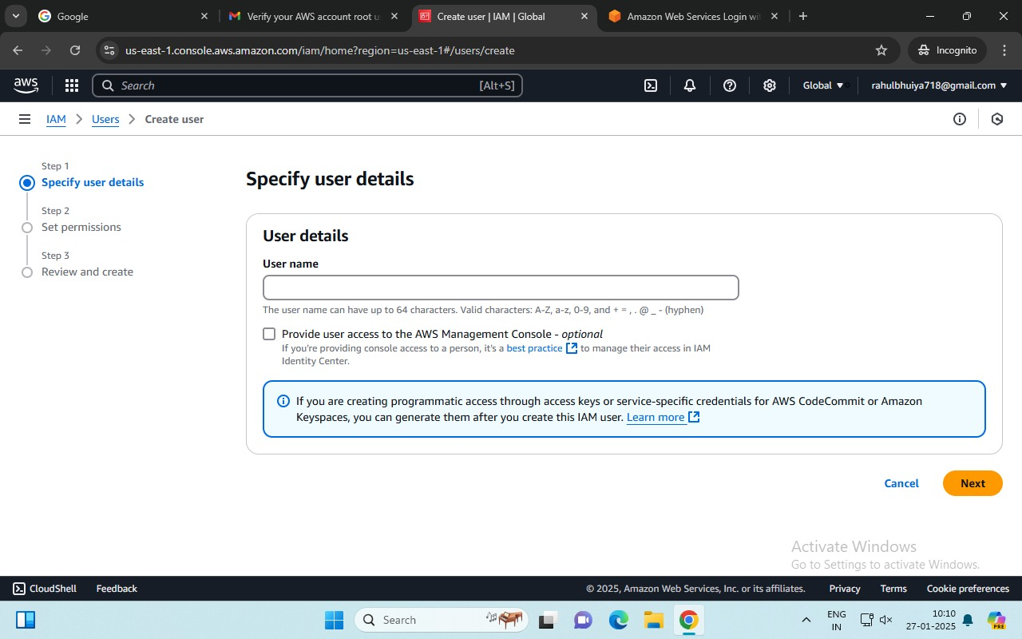

## **Add User Details:**

* + - Enter the user name (e.g., **U1**).
    - 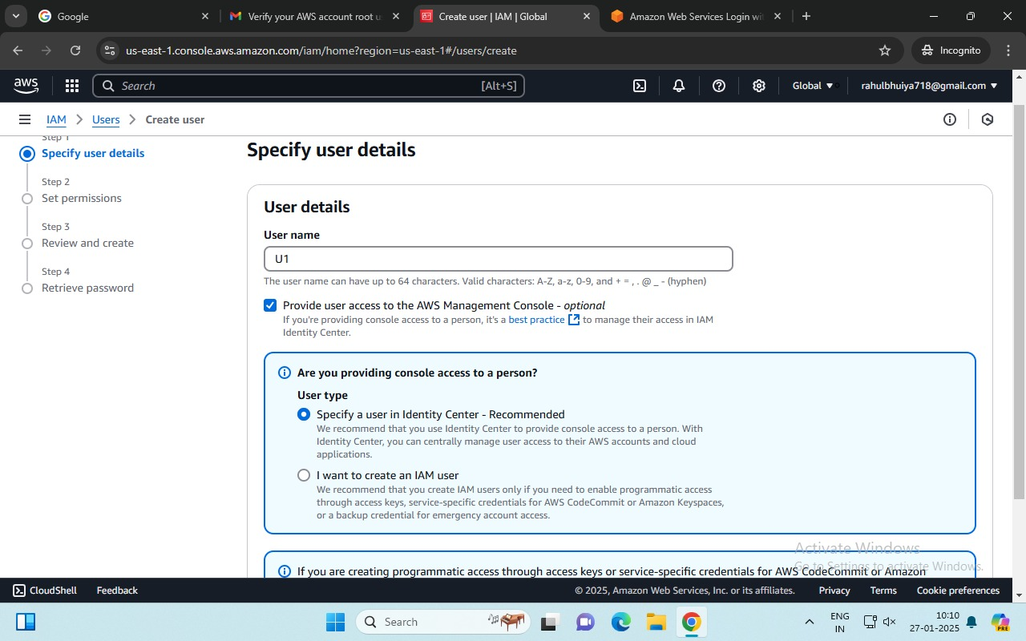Select **Access Type** as **AWS Management Console access**.

**(Creating User -> User Name).**

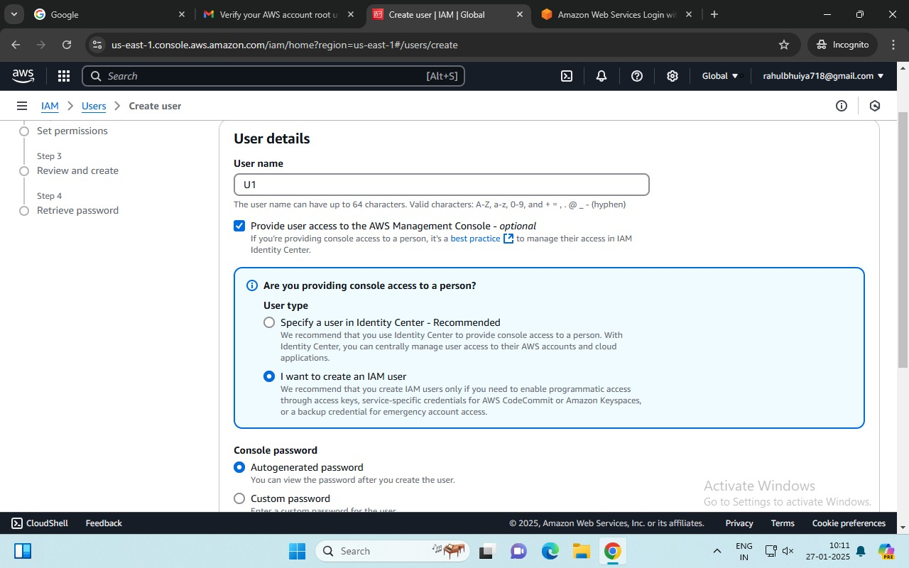

## **Set Password:**

* + - Choose one:
      * **Auto-generated password** (AWS generates a random password).
      * **Custom password** (you define the password).
    - For this exercise, enter a custom password.
    - Uncheck **Require password reset**.
    - 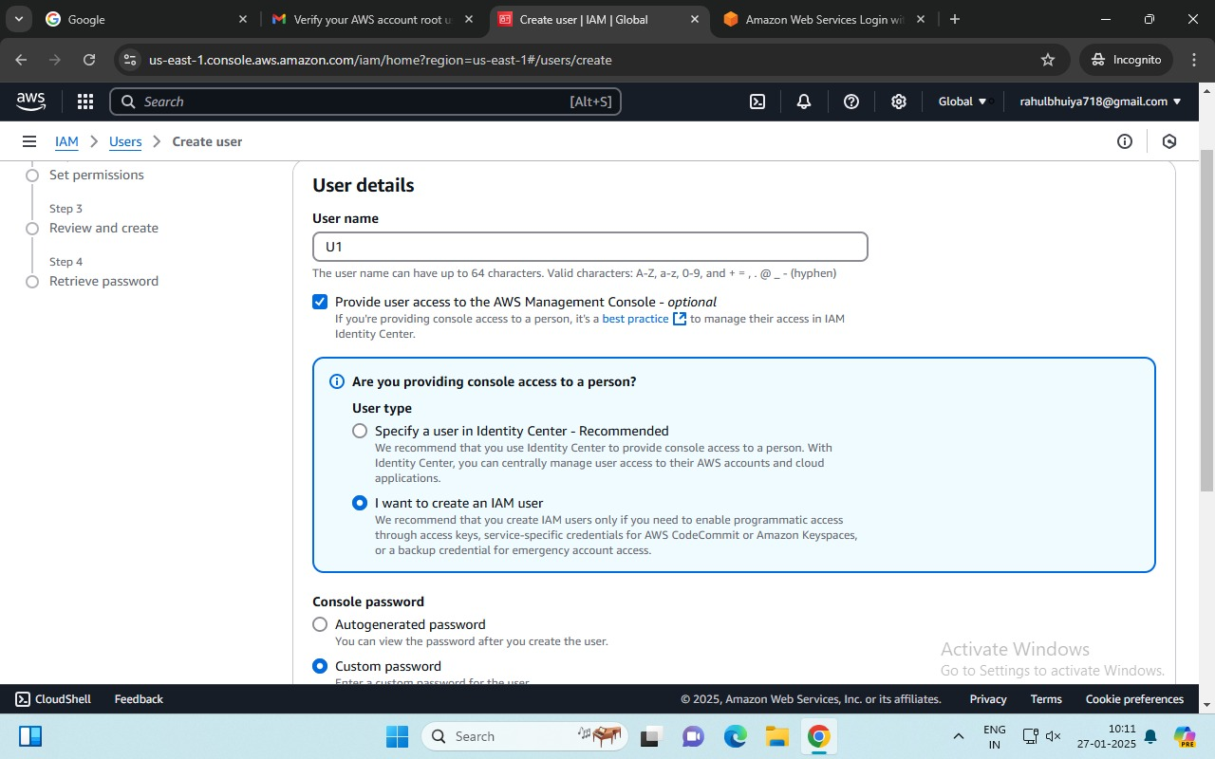Click **Next**.

## **Assign Permissions:**

* + - You can assign permissions in three ways. For now, skip this step and assign permissions later.

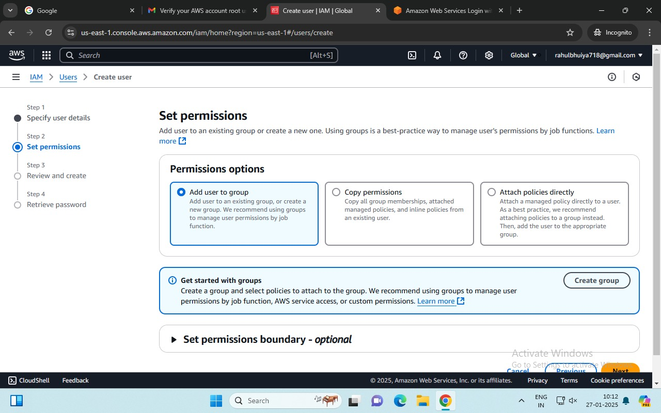

## **Review:**

* + - On the **Review** page, confirm the entered details.
    - 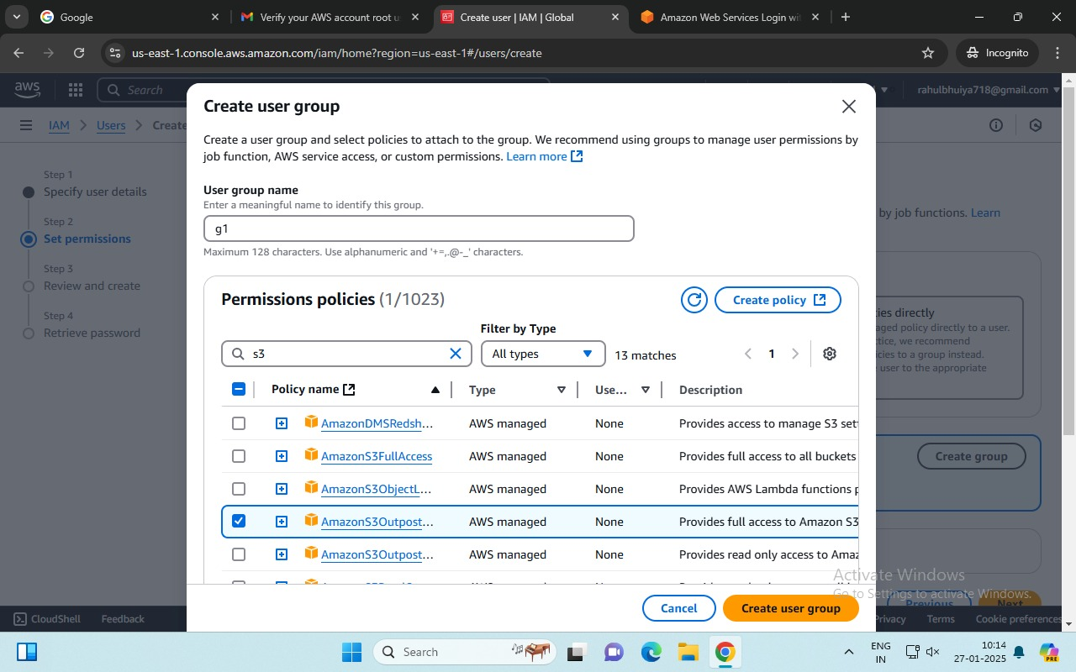Click **Create user**.

## 

## **Download Credentials:**

* + - Download the .csv file containing the credentials (username and password).
    - 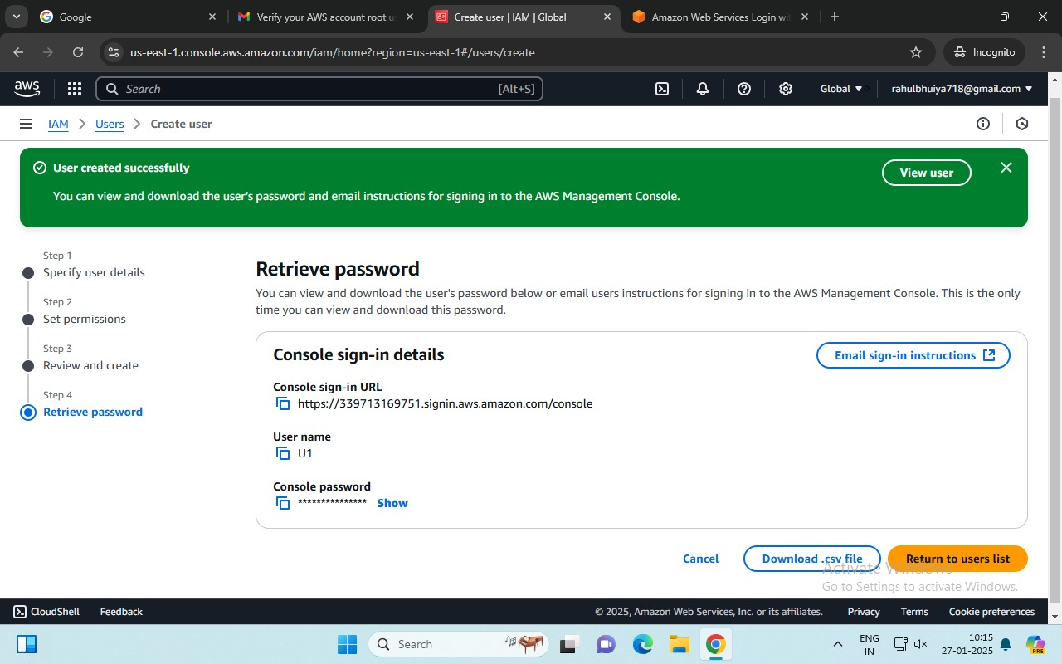Save it securely.